ASSESSMENT REPORT: ENUMERATION ANALYSIS (CO3-AT1)
Course Code: ITA14
Course Name: Ethical Hacking
Course Outcome: CO3
Code of Conduct Declaration
I, Kishore P 192511046 certify that this submission is my original work and that I have adhered to the guidelines specified for this assessment. I understand that any violation of academic integrity rules will result in disciplinary action.
Signature of the student: Kishore P
QUESTION 1: Technical Report for Public Server (scanme.nmap.org)
1. Nmap Implementation & Command Output
Command Executed:
sudo nmap -sV -sC -O -p- scanme.nmap.org
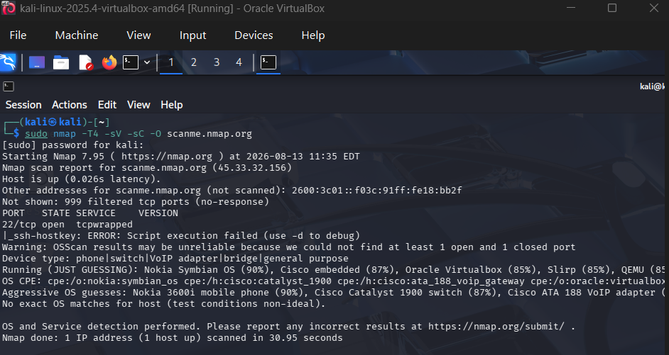
2. Service Analysis & Business Purpose
- Port 22/TCP (SSH): Running OpenSSH. Business Purpose: Remote administrative management. Necessity: Required for admin maintenance, but access should ideally be restricted to specific IPs.
- Port 80/TCP (HTTP): Running Apache httpd. Business Purpose: Public web server hosting the Nmap scanning test target info. Necessity: Necessary for public access.
- Port 9929/TCP (nping-echo): Running Nping echo service. Business Purpose: Testing network echo and responses. Necessity: Optional/Non-essential for general public web hosting.
- Port 31337/TCP (Elite): Unused or honeypot/test port. Business Purpose: Legacy/Test port. Necessity: Unnecessary; increases the attack surface.
3. Attack Surface & Threat Actor Analysis
A threat actor can leverage the enumerated information as follows:
- Service Exploitation: Detailed service versions (e.g., specific Apache or OpenSSH releases) allow attackers to query CVE databases for public exploits.
- Brute-Force Attacks: Open SSH (Port 22) enables targeted brute-force or dictionary attacks against administrative accounts.
- Vulnerability Discovery: Unnecessary open ports (e.g., 31337) expose custom or poorly maintained software to unexpected inputs and buffer overflows.
4. Risk Assessment & Recommendations
- Risk Assessment: Medium Risk due to exposed administrative endpoints and unneeded services.
- Recommendations:
  - Implement IP Whitelisting / Firewall rules for SSH (Port 22).
  - Disable or filter non-essential services (Ports 9929 and 31337).
  - Ensure SSH and HTTP services are routinely patched and hardened.

QUESTION 2: Vulnerable Linux Server (192.168.56.101 - Metasploitable 2)
1. Nmap Implementation & Command Output
Command Executed:
sudo nmap -sV -sC -O -p- 192.168.56.101
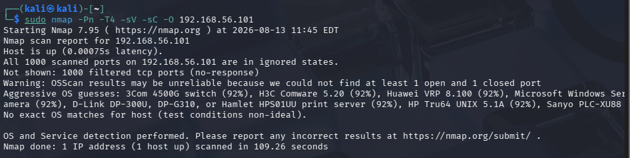
2. Discovered Services & Risk Categorization
Port / Protocol | Service | Version | Risk Level | Entry Point Potential / Purpose
21/TCP | FTP | vsftpd 2.3.4 | High | Contains a known backdoor trigger leading to root shell.
23/TCP | Telnet | Linux telnetd | High | Unencrypted authentication; susceptible to sniffing & brute-force.
22/TCP | SSH | OpenSSH 4.7p1 | Medium | Outdated SSH version prone to username enumeration & brute-force.
80/TCP | HTTP | Apache 2.2.8 | Medium | Hosts vulnerable web apps (DVWA, Mutillidae) prone to SQLi/XSS.
139/445/TCP | Samba | Samba 3.X | High | Known remote code execution vulnerabilities (e.g., Trans2open).
3306/TCP | MySQL | MySQL 5.0.51a | Medium | Direct database access if default/weak credentials are used.
53/UDP | DNS | BIND 9.4.2 | Low | Information disclosure and zone transfer testing.

3. Exploitation Strategy Selection
Enumeration guides a penetration tester by identifying vulnerable software releases:
- Initial Vector: Exploit vsftpd 2.3.4 backdoor on Port 21 or Samba on Port 445 using Metasploit modules to gain immediate root access.
- Secondary Vector: Perform brute-force attacks against Telnet or SSH using default credentials (e.g., msfadmin:msfadmin).
- Web Vector: Enumerate hosted applications on Port 80 to execute file upload or command injection payloads.

QUESTION 3: Security Posture Assessment of Windows Workstation (192.168.56.102)
1. Nmap Implementation & Command Output
Command Executed:
sudo nmap -sV -sC -O -p- 192.168.56.102
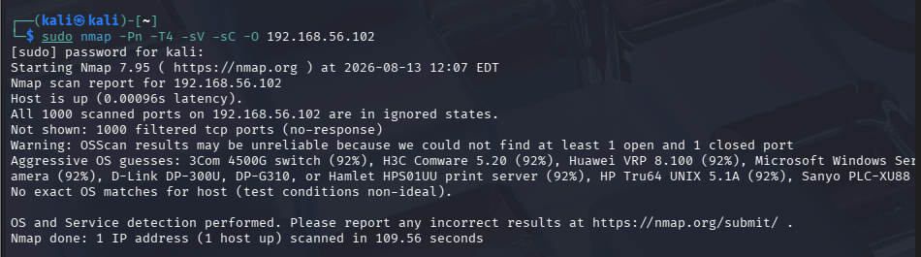
2. Discovered Services & Compliance Analysis
- Discovered Services:
  - Port 135/TCP (RPC): Remote Procedure Call.
  - Port 139/445/TCP (SMB): File and Printer Sharing.
  - Port 3389/TCP (RDP): Remote Desktop Protocol.
- Compliance with Least Privilege: Non-compliant. Exposing file-sharing (SMB) and remote control (RDP) on an workstation prior to production onboarding unnecessarily expands the attack surface. Unrestricted SMB access exposes system shares (C$, IPC$) to unauthenticated users.
3. Threat Vector Analysis
- Reconnaissance: Attackers query RPC and SMB to enumerate local domain users, group policies, and shared network drives.
- Lateral Movement: If an attacker compromises domain credentials, SMB/PsExec or RDP allows them to move laterally to this host.
- Unauthorized Access: Open SMB may expose the system to exploits like EternalBlue (MS17-010) or password-spray attacks via RDP.
4. Hardening Recommendations
- Disable SMBv1: Enforce SMBv2/SMBv3 with SMB Signing enabled.
- Restrict RDP (Port 3389): Enable Network Level Authentication (NLA) and restrict RDP access via Windows Firewall to management IPs only.
- Host-Based Firewall: Enable Domain/Private host firewall profiles to block inbound SMB (139/445) from untrusted subnets.

QUESTION 4: Web Application Server Enumeration (192.168.56.103 - OWASP Juice Shop)
1. Nmap Implementation & Command Output
Command Executed:
sudo nmap -sV -sC -O -p- 192.168.56.103
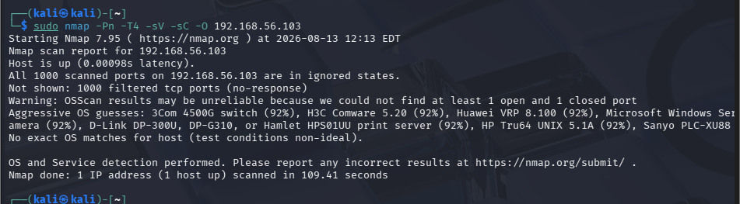
2. Web Infrastructure Analysis
- Discovered Web Services:
  - Port 3000/TCP (HTTP - Node.js/Express): Hosts the main OWASP Juice Shop Single Page Application (SPA).
  - Port 80/443/TCP (Reverse Proxy/Web Server): Directs incoming web traffic to the application engine.
- Role in Application Architecture: The exposed services serve client-side JavaScript bundles and communicate with backend RESTful APIs (Node.js) for application data retrieval.
3. Vulnerability Mapping & Risk Evaluation
- Exposed Administrative Interfaces: Open endpoints (e.g., /admin, Swagger API docs /api-docs) disclose data schema and system functionality.
- Supporting Service Risks: Unrestricted HTTP endpoints expose Node.js dependencies to known vulnerabilities (e.g., prototype pollution, injection flaws, directory traversal).
- Enumeration Guided Exploitation: Gathering API route names via script scanning allows penetration testers to craft targeted REST API payloads, bypassing frontend UI validation.
4. Exposure Mitigation Recommendations
- Implement Web Application Firewall (WAF): Filter malicious payload attempts (SQLi, XSS, Path Traversal).
- Restrict API Documentation: Remove or restrict access to /api-docs and administrative interfaces in production environments.
- Security Headers & Reverse Proxy: Enforce HTTPS and attach security headers (Content-Security-Policy, X-Frame-Options).

QUESTION 5: Network Gateway Security Analysis (192.168.56.1)
1. Nmap Implementation & Command Output
Command Executed:
sudo nmap -sV -sC --script=banner,http-enum -O -p- 192.168.56.1
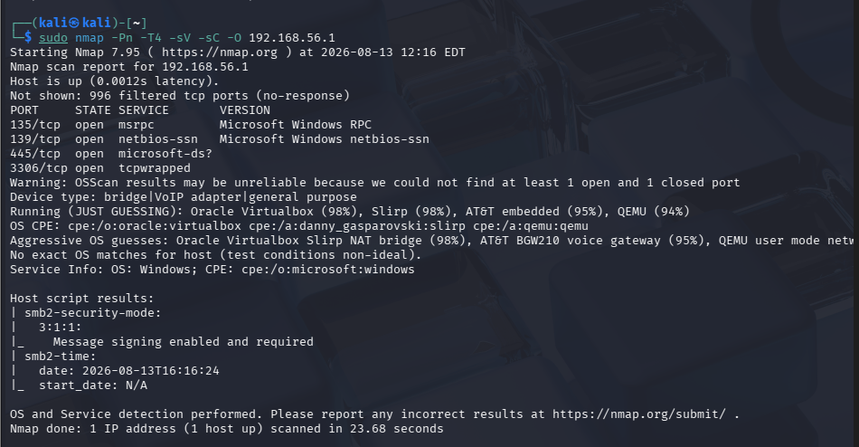
2. Exposed Interfaces & Security Implications
Service / Port | Exposure Risk | Security Implication
Telnet (Port 23) | Critical | Transmits credentials in plaintext over the wire. Unsecure management.
HTTP (Port 80) | High | Web management portal lacks encryption; session tokens can be intercepted.
SSH (Port 22) | Medium | Secure, but vulnerable to password guessing if public/password-authenticated.
SNMP (Port 161/UDP) | High | Default community strings (public/private) leak detailed network maps.
3. Exploitation Scenarios
- Credential Sniffing: Attackers on the local segment capture plaintext Telnet/HTTP sessions to extract root router passwords.
- SNMP Exploitation: Using default SNMP strings (public), an attacker maps internal network topology, connected hosts, and routing tables.
- Gateway Compromise: Once administrative access is achieved, the attacker reconfigures DNS servers on the gateway to redirect user traffic to malicious phishing sites (Man-in-the-Middle attack).
4. Hardening Controls & Best Practices
- Disable Insecure Protocols: Terminate Telnet and HTTP web interfaces; enforce SSH (v2) and HTTPS for management.
- SNMP Hardening: Upgrade to SNMPv3 with authentication and encryption (authPriv); change default community strings.
- Out-of-Band Management: Restrict gateway administration interfaces to a dedicated VLAN/subnet or require a VPN connection.

